**2.Create Student details using SQL Commands.**

**Step 1:**

**CREATE TABLE STUDENT1(stu_id int primary key,stu_name varchar(123),stu_department varchar(345),stu_course varchar(123),stu_address varchar(234));**

**Step 2:**

**INSERT INTO STUDENT1 VALUES(1,'Kevin','CSE','DAA','Kodaikanal');**

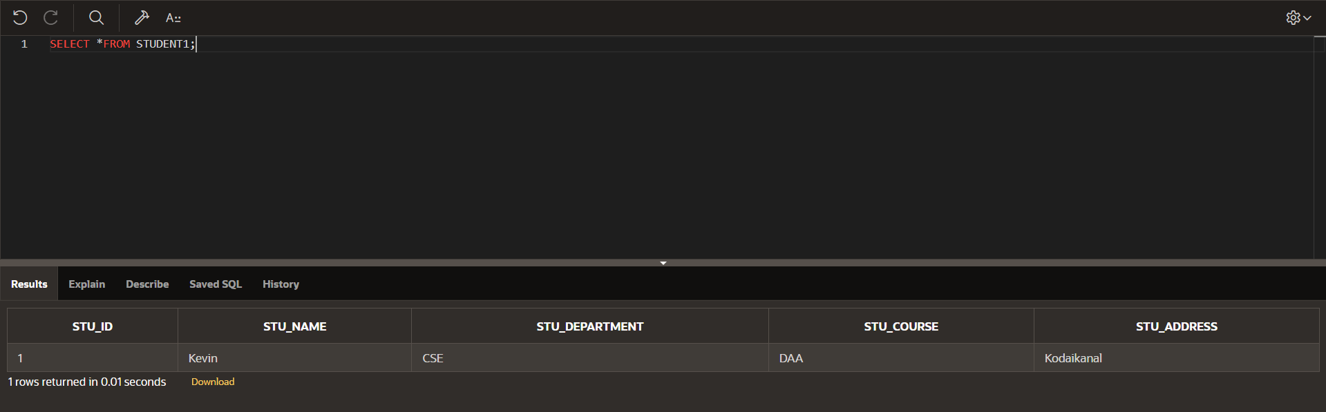

**Create Many Student details**

**INSERT INTO STUDENT1 VALUES(2,'Ben','IT','C++','Chennai');**

**INSERT INTO STUDENT1 VALUES(3,'Strange','ECE','CA','Trichy');**

**INSERT INTO STUDENT1 VALUES(4,'Peter','AI&DS','DMBS','Coimbatore');**

**INSERT INTO STUDENT1 VALUES(5,'Vasu','AIML','Java','Kanchiupuram');**

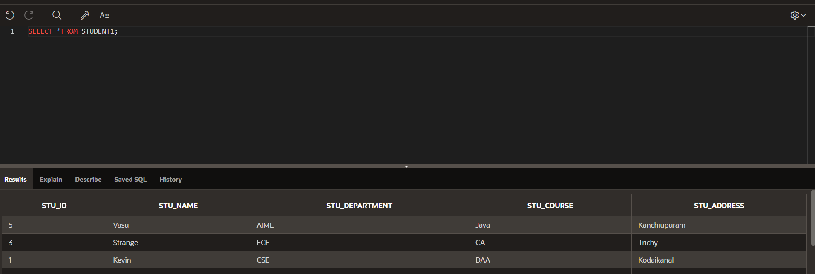

**STEP 3:**

**SQL COMMANDS:**

**ALTER TABLE STUDENT1 ADD stu_age int**

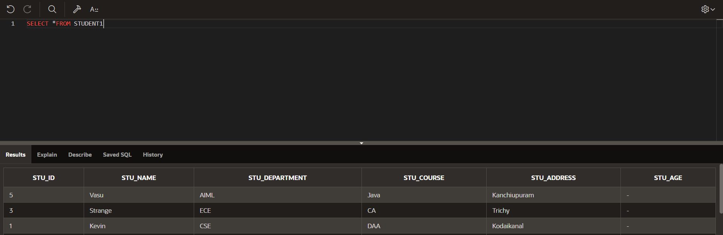

**ALTER TABLE STUDENT1 DROP COLUMN stu_age;**

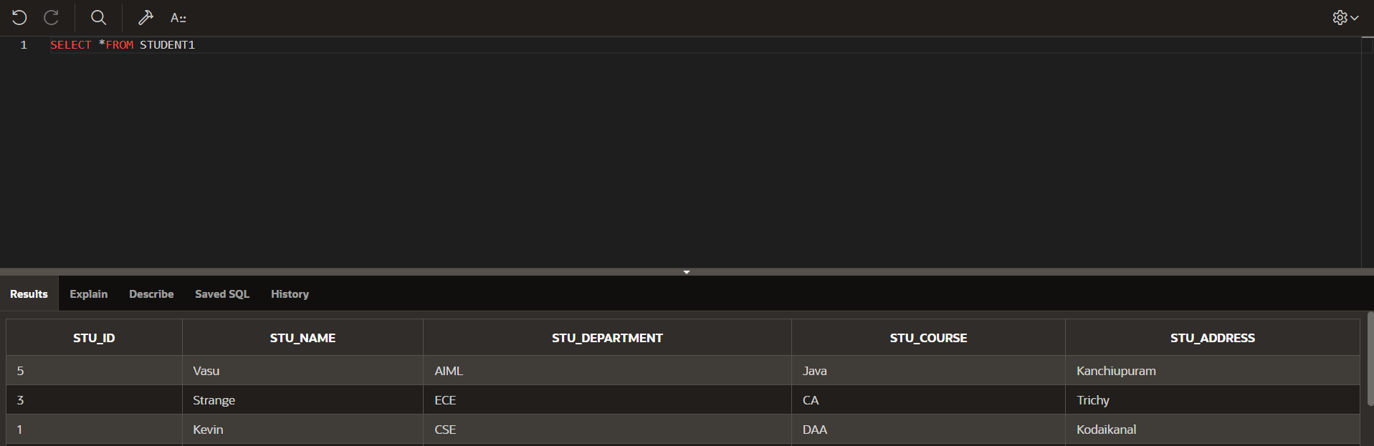

**ALTER TABLE STUDENT1 RENAME COLUMN STU_NAME**

**TO STU_FIRST_NAME;**

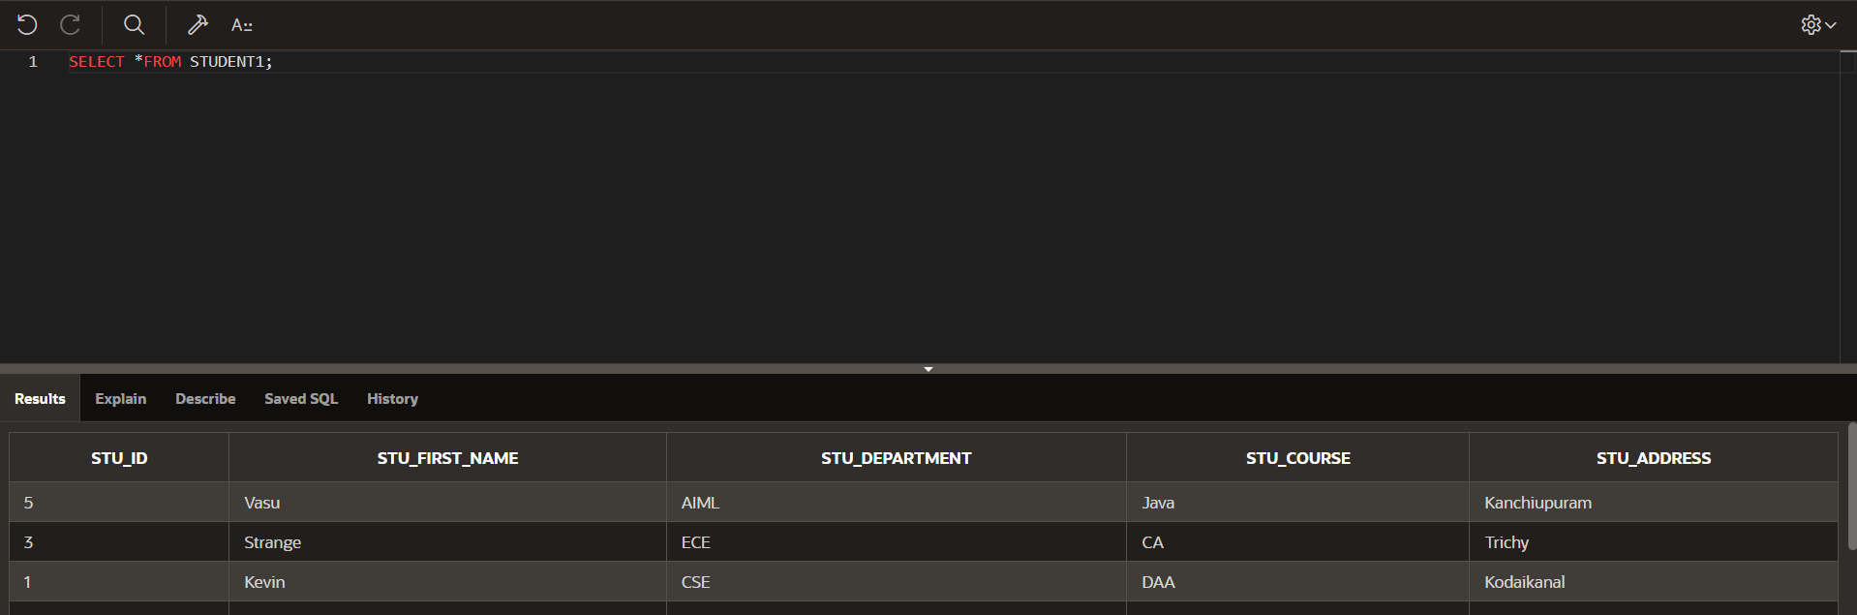

**ALTER TABLE STUDENT1 RENAME TO STUDENT_DETAIL;**

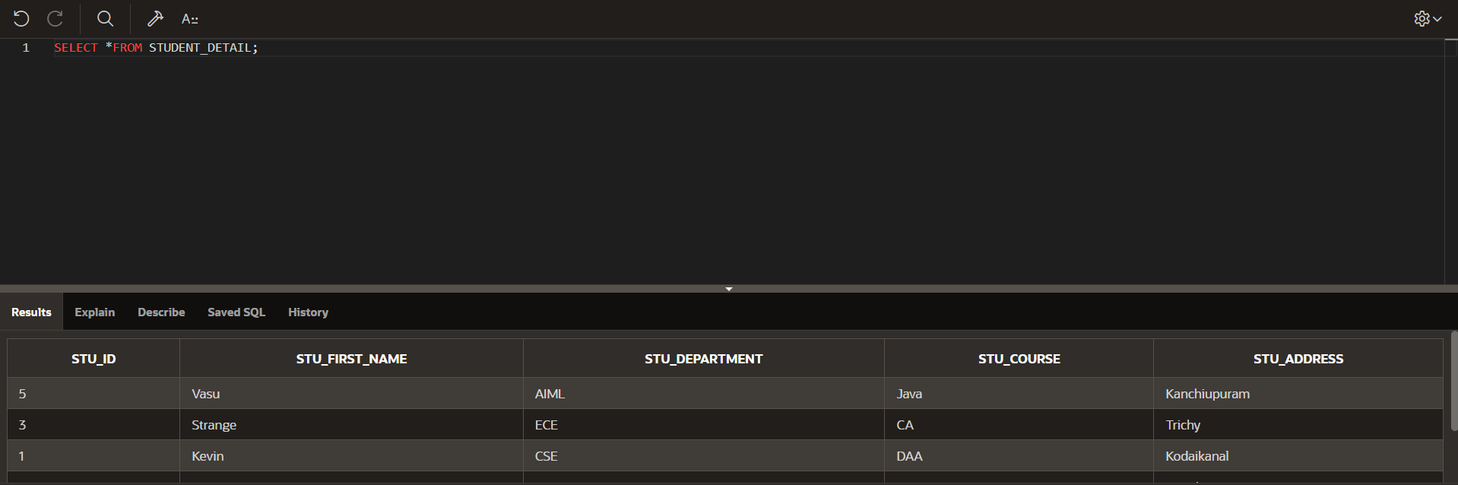

**TRUNCATE TABLE STUDENT_DETAIL;**

**The Entire table will be trunked or delete.**

**UPDATE STUDENT__DETAIL**

**SET STU_FIRST_NAME='Kiran' WHERE STU_FIRST_NAME='Vasu';**

